In 2016, MRIP saw 116 boats with a unique CLS_ID. However, these only match 103 TID #s according to the latest file from Gregg

In 2016, 112 boats self-reported trips. However, only 94 of them have an associated CLS_ID # according to the latest files from Gregg

--

Of the 94 boats that self-reported with a valid CLS_ID, only 62 are captured by MRIP

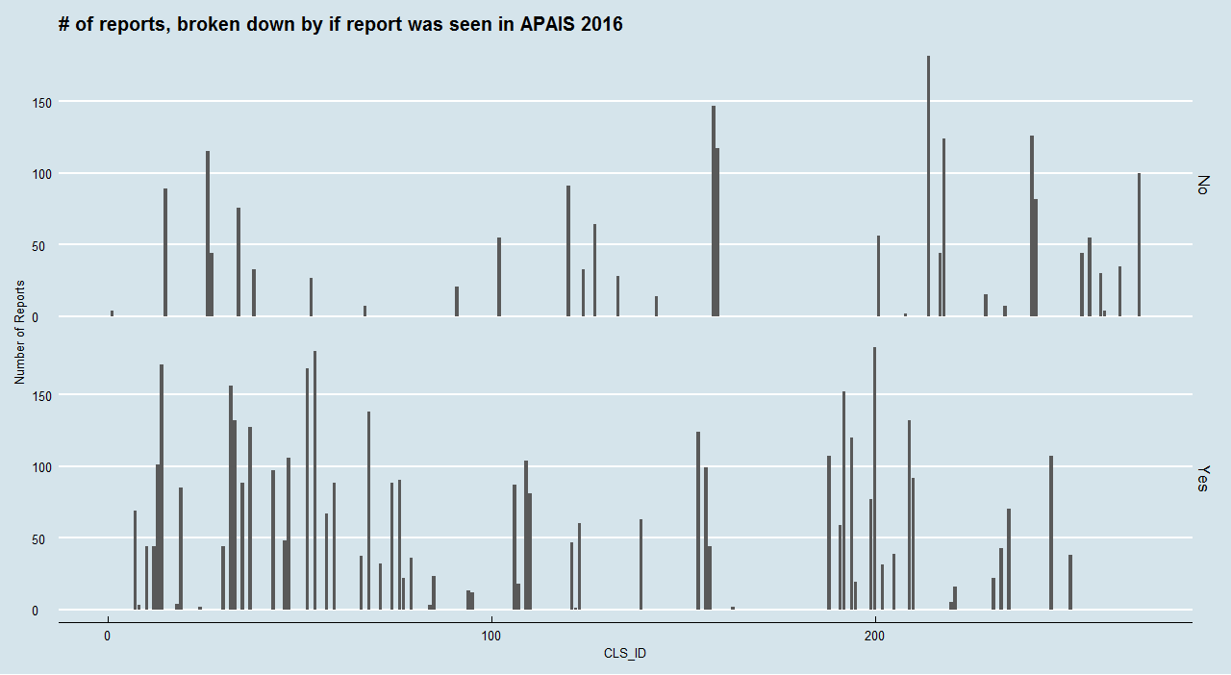

In 2017, MRIP saw 115 boats with a unique CLS_ID. However, these only match 108 TID #s according to the latest file from Gregg

In 2017, 121 boats self-reported trips. However, only 101 of them have an associated CLS_ID # according to the latest files from Gregg

--

Of the 101 boats that self-reported with a valid CLS_ID, only 66 are captured by MRIP

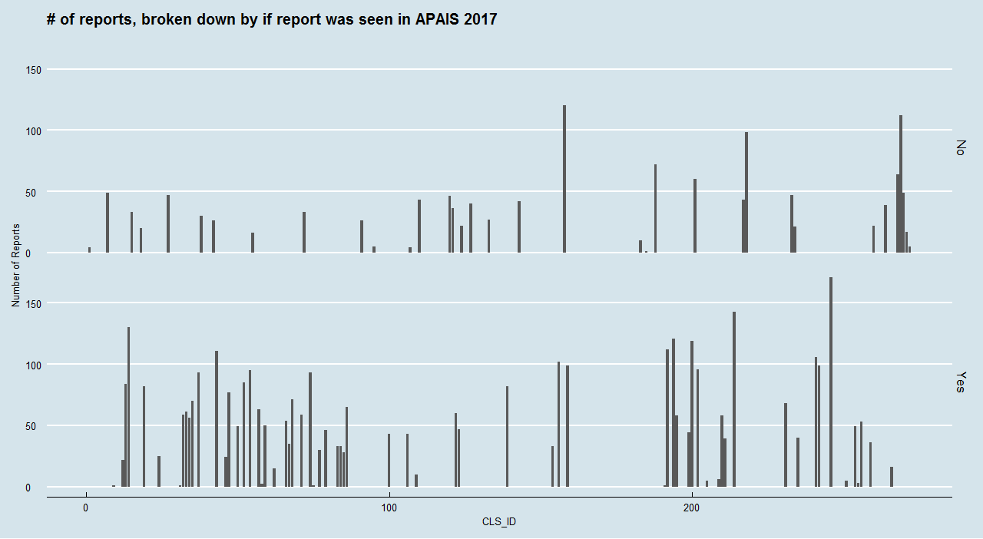

LEAVE OUT REPORTED TRIPS WITHOUT A GREGG ASSIGNED CLS_ID (THEY COULDN’T HAVE BEEN CAUGHT)

LOOK TO SEE IF OLD CLS2TID IS DIFFERENT FROM NEW ONE

CLS2TID MIGHT CHANGE MIDYEAR – MULTIPLE TIDS FOR A SINGLE CLS_ID BUT THAT IS OK